Simple device for laser-wavelength measurement with a ruler
Guido Pegna

I. INTRODUCTION

In general all the phenomena which depend on the color of the light may be used to determine its wavelength. These are essentially refraction, interference, diffraction and some form of photoelectric effect. All of these have been used and many proposal have been published¹⁻⁵. Less known and pursued is the idea of using very large spacing diffraction grating in grazing incidence, following an idea originally proposed by Carrara⁶ in 1924 for x-ray analysis and revisited by R. W. Ditchburn⁷ in 1945 and later by A. Schawlow⁸ for visible light. Such an interesting possibility is retrived here related to a new deduction of the expression of the wavelength and to a simple, low cost, compact and self contained apparatus for the precise determination of wavelength of laser diodes.

II. Gratings in grazing incidence

The equation for any grating, linking the angle of incidence α, the angle β_{k} that corresponds to the diffraction ray of order k, the grating spacing p and the wavelength λ, is :
k λ = p (sin α + sin β_{k}) (1)
The arrangement of the setup in case of a reflection grating acting at gazing incidence is shown in figure 1, where the angles are much larger than the real ones. In this case being the angles α and β near 90° it is more convenient to to introduce their complements i = 90° - α and r = 90° - β ; so eq. (1) becomes:
k λ = p (cos i - cos r_{k}) (2)
The sign of the second term in eq. (2) is negative because the diffracted rays rays are on the other side of the normal to the grating plane with respect to the incident ray. It is also interesting that the grazing incidence is a mean of making large spacing gratings to behave like a grating having a much smaller tight spacing p’ = p sin i.

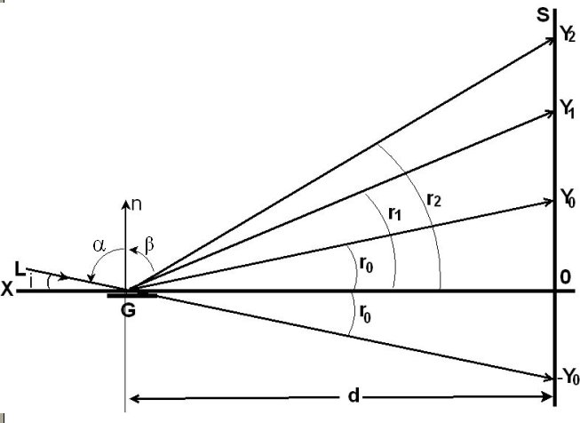
FIG. 1. S is the screen on which the diffraction fringes are displayed, placed at distance d from the grating G. The first spot at the position y₀ is due to specular reflection: therefore r₀ = i, the incidence angle, if all the angles are measured with respect to the grating plane OX. The fraction of the undeflected laser beam determines the spot in the symmetrical position -y₀ on the screen.

The value of λ may be determined by measuring the various positions y_{k} of the diffraction fringes with respect to the point O on the screen placed at distance d from the grating. Point O is determined as the midway point between the spot of the undeflected ray (at position –Y₀) and the spot due to specular reflection by the ruler (at position Y₀). Eq. (2) may be calculated directly: in figure 1 it can be seen that the cosines of the angles are the ratio between the length GO (i.e. the distance d between the grating and the screen) and the hipotenuse of the various triangles GOY_{k} which may be calculated with the theorem of Pythagoras:

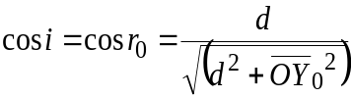 (3)
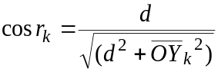 (3a)
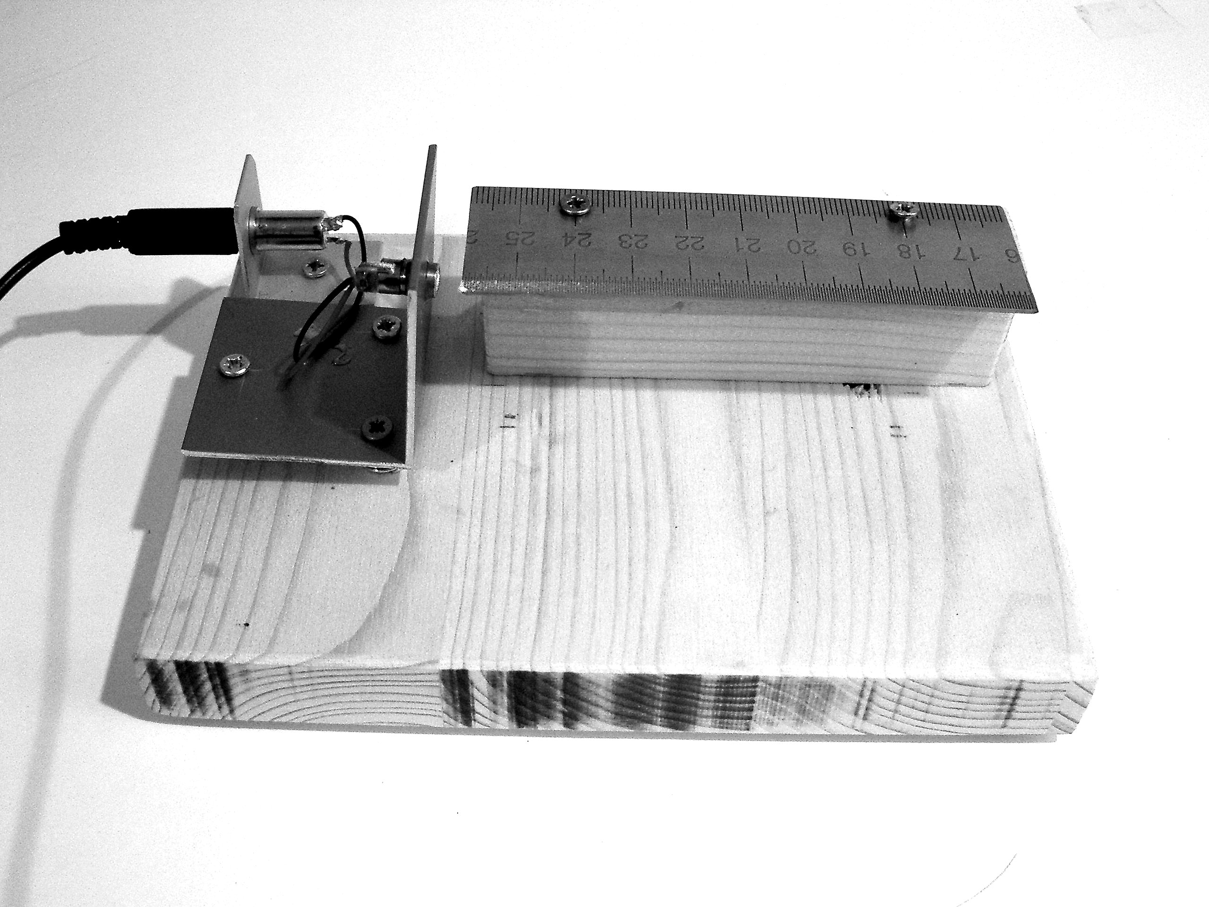
FIG. 2 : General view of the device, with the components mounted on a wooden base. The ruler length is 10 cm. In this photograph the laser is turned on, and the ruler area illuminated by the red laser beam is visible.

From eq. (1), for the maximum grazing incidence α ≈ 90° and β ≈ −90°, one gets:
k_{m} ≈ 2p/λ
This value of k is named the maximum diffraction order. It origins from the maximum absolute limiting values that may be assumed by sin α and sin β_{k} , with k>0. In our experiment p = 0,5 mm and λ = 0,65 μm; in the extreme case of maximum grazing incidence k_{m} would be greater than 1500; in a more realistic case, k_{m} is much lower. Despite the light intensity decrease with k, (as shown later in figure 4), more than 25 fringes are still easily visible on the screen.

III. Example of experimental results

In Figure 3 the diffraction fringes may be seen as they appear on a cardboard screen placed 30 cm from the ruler’s end. Obviously, placing the screen at a larger distance does improve the accuracy

in measuring the y_{k} values.

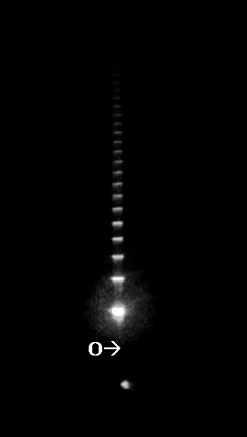
FIG. 3. Photograph of the diffracted spots on the screen. The diffraction fringes that can be viewed by naked eye reach easily the 25th order! The lowest spot is generated by the fraction of the laser beam that passes alongside the ruler’s edge. The second spot (much brighter) is the mirror reflection by the ruler. The position of the reference point O of figure 1 is midway between these two first spots.

The calculations of the values of λ from the measured Y_{k} and d by equations (2), (3) and (3a) was performed by a simple BASIC program. In the following Table I are reported the calculated values of λ vs. the corresponding Yk on a screen placed at d = 268 cm from the end of the ruler.
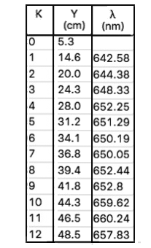
Table I
Positions y_{k} of the first twelve fringes and the calculated wavelength values λ
The data shown in Table I give an average wavelength λ = (652 ± 5) nm. The real value for these laser diodes in unknown, the dealer gives only a nominal value of 650 nm.
The data of the table were the result of single measurements, with absolute error of about 2 mm. The standard errors could be reduced by making a series of determinations on each fringe, making this method effectively useful for fast laser characterization also in the research laboratory work.

V. Construction details

The 5 mW laser diode modules used in this setup were purchased in Internet at very low cost in group of 10 pieces⁵. These include a microcircuit that connected to a power supply of about 5V provide a controlled 40 mA current to the laser diode. They produce a well collimated and intense beam. The laser diode is mounted with its collimating lens inside a metallic cylinder (10 mm long and 6 mm diameter).
The power supply may be a common 4.5V dry battery or a common USB cellular phone charger.
The screen may be placed at few meter distance d from the light source: the evaluated precision of the wavelength increases with the distance and with the accuracy of the measured y_{k} values.
The laser module is fixed by two-component epoxy resin onto a 6mm hole in the aluminum bracket which is attached to the wooden base by three screws and three compressed spring (see Figure 5): this setup allows to adjust the height and the tilt of the laser beam with respect to the ruler grating.
The grating is obtained by cutting a piece 10 cm long from a metal ruler graduated in half-millimeter pitch (p = 5 · 10⁻⁴ m). The black paint on the marks of the ruler may be removed with a cotton soaked in acetone, leaving only the ticks that are engraved on the ruler.

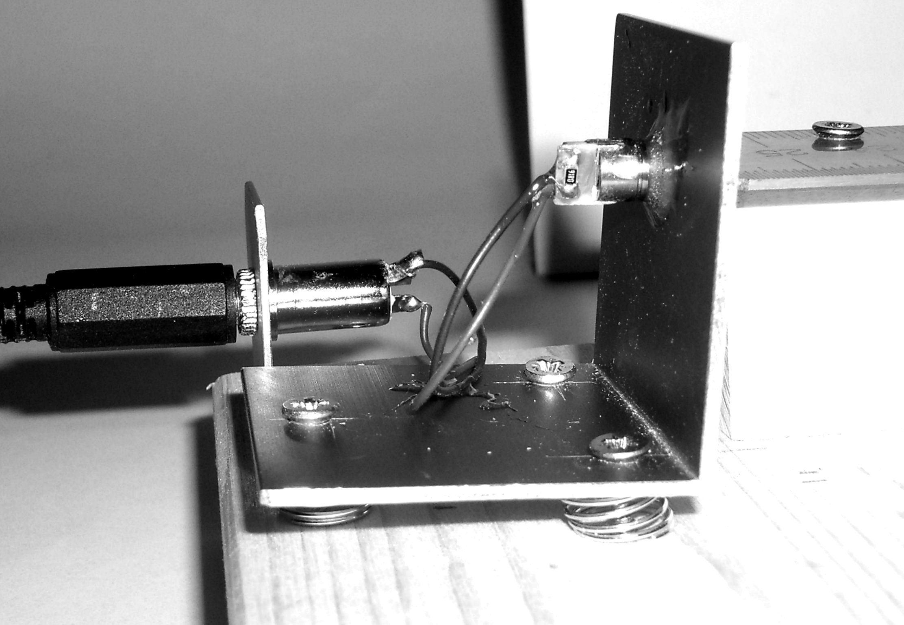

FIG. 5 : The laser module is inserted in a hole at the top of the aluminum bracket and glued with epoxy resin. Three screws allow adjusting the height and the angle of incidence. Note the compressed springs under the aluminum bracket.
The ruler is fixed to a wooden strip (20 × 30 mm cross-section and 10 cm long). The bracket with the laser module may be first positioned ad secured in the middle of the short side of the wooden base; then, turn on the laser and secure the support of the ruler so that the laser beam impinges onto the graduated ruler’s edge, as shown in Figure 2, but with a small fraction of the beam that should pass undisturbed alongside the ruler’s edge. This not deflected beam fraction is important, because it produces on the screen a small spot that serves as a reference to determine the location of point O of Figure 1 that is the zero reference for the measurements of the positions of the diffracted fringes.

Precise positioning of the ruler's support is possible if one makes two larger holes (e.g. 8 mm diameter) on the wooden base, and then using wood screws with 12 mm washers between the head’s screw and the base.
To get a better definition of the spots on the screen, a diaphragm with a 1 mm diameter hole should be placed immediately in contact with the output lens of the laser beam.

VIII. CONCLUSIONS

The deduction of the expression of the wavelength of a laser diode here proposed is quite straightforward and makes use of no approximation. The apparatus is based on very low cost and immediately viable laser diode, which are easily found in different colors. It is simple, easy to adjust and self contained, avoiding the need to assemble and align separated supports for the components. Once built and after having adjusted the laser position, the device is immediately ready to perform measurements, requiring no further adjustments. It is font of surprise to note how a relatively coarse instrument like a metallic workshop ruler is useful for a precise determination of a minute physical quantity like the wavelength of light. The construction of this little apparatus might be an interesting project for a group of students of introductory physics courses.

REFERENCES
* pegna@unica.it
+ torzog@gmail.com
1 rifrazione
2 T. Catunda, J. Sartori, and L. A. O. Nunes, “Plane wave interference: A didactic experiment to measure the wavelength of light”, Am. J. Phys. 66 (6), 548 (1998).
- T.B. Greenslade Jr. “Quick measurement of wavelength of laser light”, T.P.T 35, 309 (1997).
- interferometro di Michelson
5 Sanjukta Roy, Saptarishi Chaudhuri, and C.S. Unnikrishnan, “A simple and inexpensive electronic wavelength-meter using a dual-output photodiode”, Am.J.Phys. 73, 571 (2005).
6 N. Carrara, Nuovo Cimento, vol.1, p.107, (1924). In 1925 Compton and Doan were the first ones to obtain X-ray spectra using this method.
7 R. W. Ditchburn, “Determination of the Wave-Length of Light by Diffraction at Grazing Incidence”, Am. J. Phys. 10, 195 (1942) .
8 A.L. Schawlow, “Measuring the wavelength of light with a ruler”, Am. J. Phys. 33, 922-932 (1965).
9 There are many websites selling laser modules at low cost. The following one offers 10 pieces for 4,99 GPB + 9,67 GPB for shipping: http://www.ebay.it/itm/10-x-mini-650nm-6mm-3V-5mW-Laser-Dot-Diode-Module-Head-WL-Red-/271949872154?hash=item3f5179bc1; a cheaper seller (10 pieces for 2.88 $ + 3$ shipping costs) requires a longer time for shipping: http://www.ebay.com/itm/10pcs-650nm-6mm-5V-3V-5mW-mini-Red-Laser-Dot-Diode-Module-Laser-Head-WL-/131300354566?var=430595180766&hash=item1e921c6a06

